**PROBLEM#03**

**Q** :Write a program for calculator using **if** , **else if** ,**else** statements.

**SOURCE CODE:**

#include <stdio.h>

int main(void){

//variables

char operator;

float num1,num2,add,subract,multiply,division;

//heading

printf("\n\t\t********\t CALCULATOR \t********\t\n");

//input operator

printf("\n Enter Operator <+,-,*,/> :");

scanf("\n %c",&operator);

//input number one

printf("\n Enter Number 1 : ");

scanf("%f",&num1);

//input number two

printf("\n Enter Number 2 : ");

scanf("%f",&num2);

// if addition

if(operator == '+'){

add = num1 + num2;

printf("\n\t\t********\t ANSWER \t********\t\n");

printf("\n The Addition of these numbers are : %.0f",add);

}

//if subraction

else if(operator == '-'){

subract = num1 - num2;

printf("\n\t\t********\t ANSWER \t********\t\n");

printf("\n The Subraction of these numbers are : %.0f",subract);

}

//if multiplication

else if(operator == '*'){

multiply = num1 * num2;

printf("\n\t\t********\t ANSWER \t********\t\n");

printf("\n The Multiplication of these numbers are : %.0f",multiply);

}

//if division

else if (operator == '/'){

division = num1 / num2;

printf("\n\t\t********\t ANSWER \t********\t\n");

printf("\n The Division of these numbers are : %.2f",division);

}

getche();

}

**OUTPUT:**

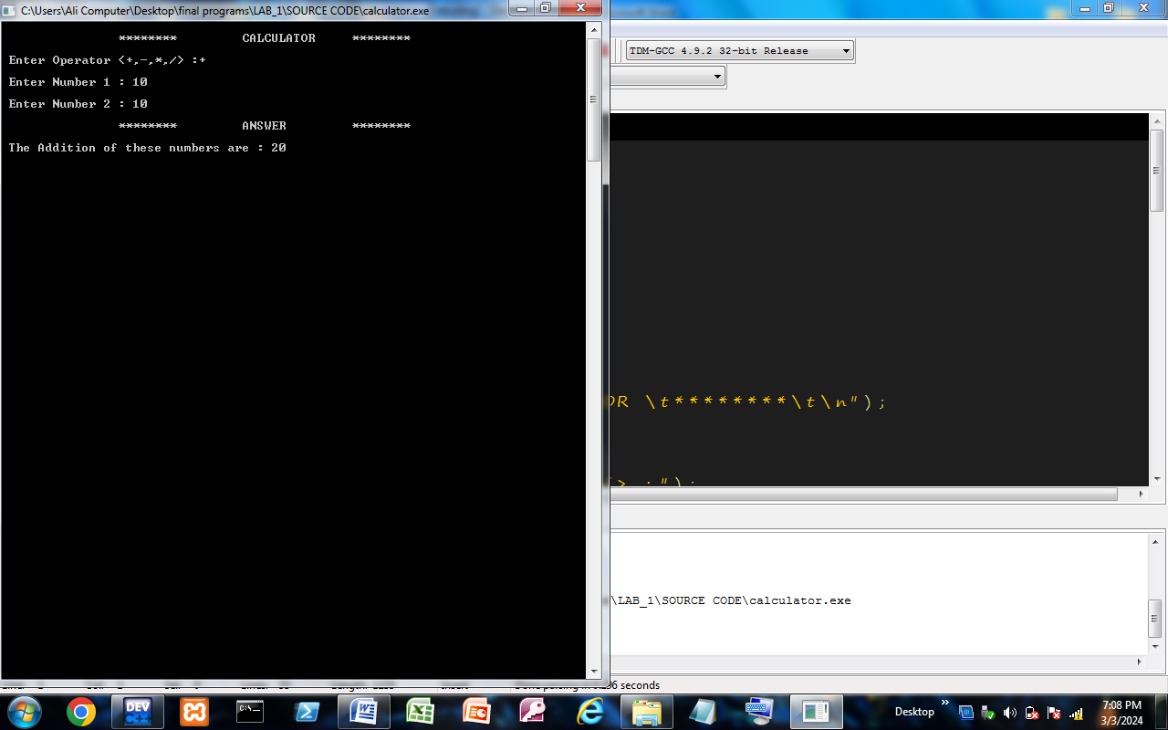

Made By :

***Kashan Ali Khan(BS-SE)***